Universal Charging Friend U.C.F.

Alfred Berrios, Tristan Byers, Melanie Cromer, Michael Matthews

School of Electrical Engineering and Computer Science, University of Central Florida, Orlando, Florida, 32816-2450

Abstract — One main unit connected to three possible power sources; solar, kinetic and electric grid power via a DC wall adapter. The power is harvested in one of these three ways and then transferred to a battery for storage. The battery may discharge through a USB port and charge most 5 volt electronic devices. The solar power consists of three solar panels and produces 12 volts at approximately 300 milliamps. The kinetic power is a hand crank generator producing 8 to 9 volts at approximately 300 milliamps. The wall adapter delivers 15 volts at 1.5 amps. At any moment, only one of the three power sources can charge the 7.2 volt 1200 mAH battery. An LCD will display which power source is currently charging the battery as well as the battery capacity.

Index Terms — Batteries, Energy Harvesting, Power Conversion, Power Measurement, Solar Energy.

I. Introduction
One of the most important factors in portable electronics is battery life, and harvesting energy from nature provides an easy and readily available method to achieve this goal. The kinetic and solar power sources on the Universal Charging Friend (UCF) are capable of charging an internal battery that in turn can charge a variety of USB devices. Three panels of solar cells and a kinetic generator are used to convert solar and kinetic energy, respectively, into electricity to trickle charge a set of NiMH batteries through DC power conversion. Also built in to the design is an AC-DC wall adapter that can fast charge the batteries. The PIC microcontroller samples the three input sources multiple times a second, converts the sample from analog to digital, and displays the present power source and battery voltage onto an LCD screen. The device can charge various 5V electronics such as MP3 players, cell phones and GPS devices via the USB port. Also available in the UCF are power saving features such as a push button for turning on and off the unit and a nighttime LCD backlight which automatically shuts off after 15 seconds.

II. Components
A. Solar Power
Photovoltaic cells were utilized as one means to provide power to the UCF. These cells were chosen because of the nearly unlimited power which can be provided by the sun. Several factors affect the power supplied by the photovoltaic cells. The surface area available for use directly determines the maximum power which can be obtained via the photovoltaic cells. The angle of incidence compared to the normal angle from the sunlight determines the power capturing capacity in comparison to the maximum available. The quality of the solar cells which is described by the total efficiency of the photovoltaic cells determines what power, from the sun, can be harnessed. Temperature of the cells can affect the efficiency of the photo voltaic properties. Assembly of the solar module with individual photovoltaic cells were factors in overall power production.
The total area used for solar power collection with the use of photovoltaic cells is approximately 75mm x 600mm. The amount of power available is determined by the total amount of atmosphere between the photovoltaic cells and the sun. The power available without the atmosphere is 1367W/m². The intensity of light is reduced by approximately 30% of its original value, by the absorption of the atmosphere. In an equation this would be written as

$I=1367{\left(1-.3\right)}^{AM}$ (1)

where $I$ is the sun light intensity at the location. When determining the maximum amount of power supplied ($P_{s})$ to the surface of the UCF the following equation will be used

$P_{s}=I*A$ (2)

where A is the surface area which will be exposed to the sunlight. This equation assumes an incident angle normal to the surface of the UCF facing the sun. The angle of the incoming beam radiation (the angle of incidence) greatly affects the usable solar energy.
The varying values of light intensity greatly increase the need for maximum use of what is available. The angle of incidence between the light source and the PV cell directly affects the captured solar power. The UCF will require a means adjusting the orientation since the beam radiation component collected is proportional to the cosine of the angle ɣ between the incident beam and the normal to the plane of the collector as seen in Figure 1.

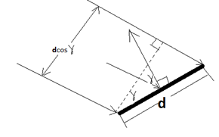

Fig. 1. Angle of incidence effect of collector tilt on effective area presented to the beam component of radiation.

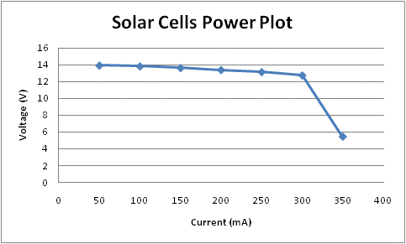
The cell quality provided by the manufacturer, Silicon Solar, is 13.00 - 14.49%, which limits the max useful power from 130 W/m² to 144W/m². The spectral response curve below in Figure 2 depicts the light wave lengths, which the photovoltaic cell is capable of absorbing. The total expected power provided by the photo voltaic cells used would be approximately 6.5W.
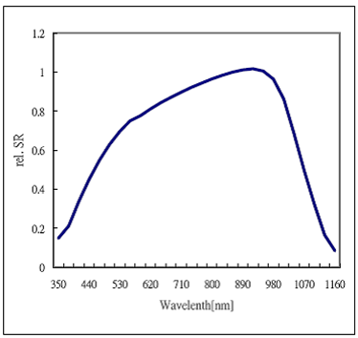

Fig. 2. Spectral response curve of light wave lengths.

The use of photovoltaic cells requires direct exposure to sunlight, which inherently causes heating of the material. The increase in temperature directly affects the band gap of the semiconductor material and reduces the maximum voltage across the PN junction. In Table 1 below the changes in current, voltage, and power when multiplied with the temperature change from 27°C is shown.

TEMPERATURE COEFFICIENTS

Current Temperature | ἁ (Isc) | 0.08% / °C
Voltage Temperature | ᵞ (Pmax) | - 0.33% / °C
Power Temperature | ᵝ (Voc) | - 0.35% / °C

Table 1. Temperature coefficients for current, voltage, and power.

The photovoltaic cells were assembled to achieve maximum voltage output to ensure the battery charging system requirements were met. Twenty-five photovoltaic cells rated at 700mA were connected in series which provided a voltage approximately 14V open circuit. The power plot is shown below for varying loads.

Fig. 3. Power plot for solar cells.

The total usable power will be less then tested because of the diodes within the circuit as well as the various resistors and current limiters.

B. Kinetic Power
Many ideas were researched to decide on which type of kinetic generator should be used for the UCF. The simple hand generator, making use of Faraday’s law, proved to be the most efficient and economical choice. The main components needed to construct such a generator are a small DC motor, a gear system working together to jump up the rpm’s of the motor, and a handle so the user can spin the network of gears.
The gear ratio of the kinetic generator is 12.6. It consists of a handle which connects to a network of four gears. The DC motor is a scrap motor obtained from a surplus store. The final crank produces around 8 to 10 Volts when it is spun clockwise and (-)8 to (-)10 Volts when spun counter-clockwise. In order to power the battery when the generator is spun in either direction, a series of Schottky diodes were added to form a full wave rectifier. Below, in Figures 4 and 5, are two images displaying the sketch up of the kinetic generator and an actual image of the built generator.

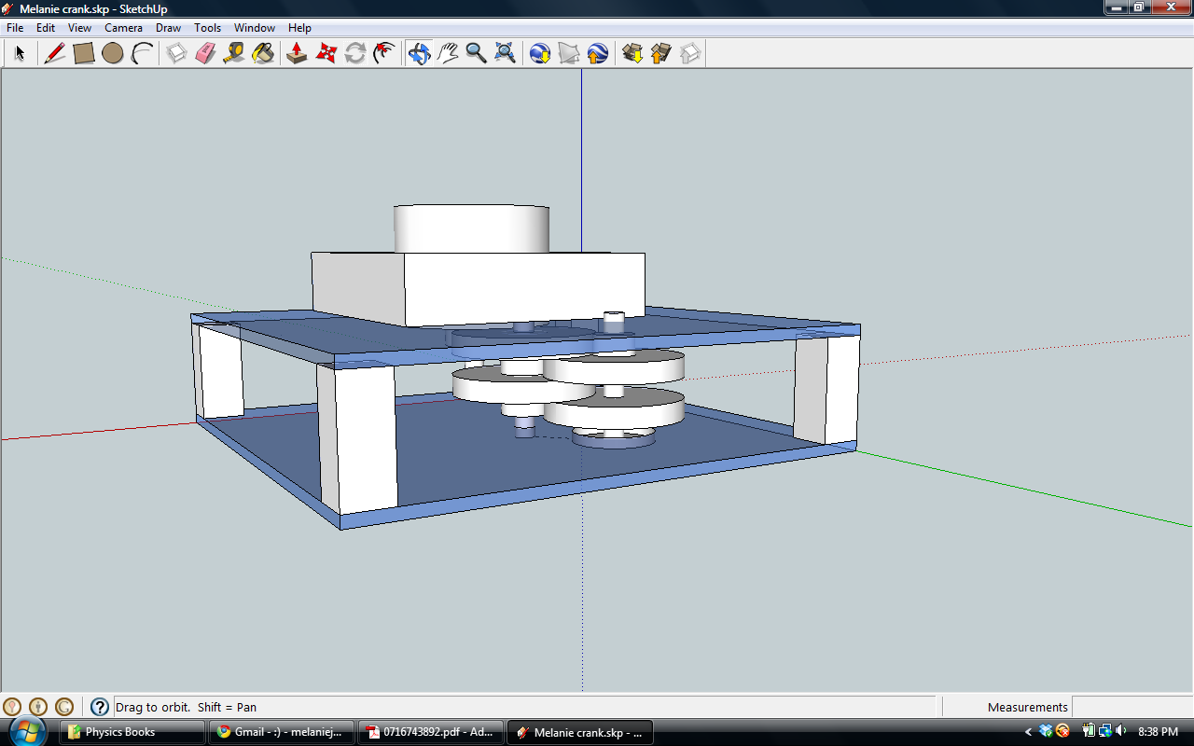

Fig. 4. This is a simplified sketch of the design for the kinetic generator using Google Sketch Up software.

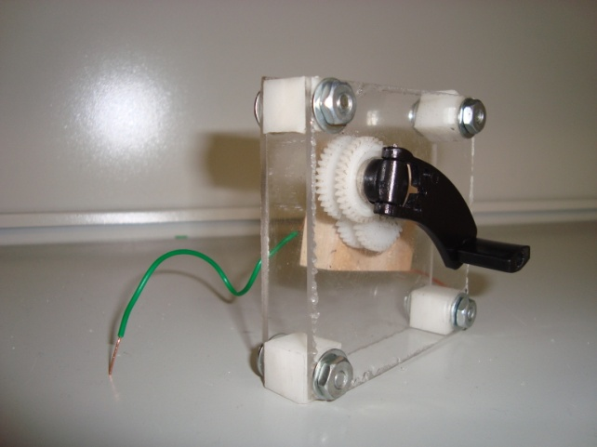

Fig. 5. This is the final device used for the kinetic generator on the UCF which was based on the sketch shown in the previous figure.

D. Battery
It was decided to use nickel metal hydride components for the system due to lower cost, lower maintenance and good energy density which will be beneficial to the project. Some reasons for using nickel metal hydride instead of the lithium ion battery system are cost of materials, complexity of circuit precautions and safety. Li-ion batteries do offer higher energy-to-weight ratio than nickel metal hydride; however, the other main issue was the voltage generation of the kinetic generator. Under testing conditions the kinetic generator could not match the voltage levels necessary for the larger of the batteries. The decision was then to lower the capacity of the battery as well as change the battery cells due to the strict charging procedures associated with lithium ion. Since the kinetic generator measured about 10V DC at a steady crank with no load it was decided to use a lower voltage battery for the project so that the kinetic generator could be utilized. Even though additional measures could have been taken in order to proceed with the lithium ion chemistries, the overall benefit of the batteries are eliminated when dealing with less peak voltage. There is little weight issues with such a change in design. The weight of the batteries is not a concern with the design since the solar cells and the kinetic generator are both light. The hinges along the ends of the project makes up most of the weight along with the battery system. Since the circuit protects the cells from overcharge and over discharge, it can reduce but not eliminate the danger in working with such components. The project is now more efficient and safe because if the lithium ion cells were not charged properly, the threat of a cell exploding would be unacceptable. The overall design of the charging circuit helps take into account such methods of safe charging as temperature, voltage detection, and a safety timer interrupt that will disconnect the charging of the battery if necessary.
The overall goal of the product is to be efficient not only in the power generated from the solar panels but also the energy from the battery to be sufficient to the output USB port. In order to optimize the performance of the power to the devices via the USB, certain mechanisms must be considered. One component that is critical to the design of the battery charger is a power converter to make sure the port is receiving the necessary 4.75V to 5.25V required for the USB-driven devices. Preferably, the battery should power 5V exactly out to the devices. The DC-DC converter is a switching regulator for the 5V output of the USB. The battery will hold a charge of around 6-8V which is higher than the 5V required, so an efficient way of stepping down the voltage is necessary for the design of the UCF. Various DC-DC converters can be purchased which are linear and are sufficient for voltage levels which are not much higher or lower than the needed output. However, the excess energy is given off as heat and will not be efficient using such a high initial voltage. So another design of the converter is essential to the product. Given that the power efficiency is

E = $\frac{Psystem}{Pconverter+Psystem}$, (3)

and some converters can have as much as 10% to 40% inefficiency, it is crucial to the project that the entire system be as proficient as possible.
Since it was decided to use nickel metal hydride cells in place of Li-ion, the Maxim 712/713 fast-charge controller for NiMH batteries was chosen for its efficiency and other advantageous features. The charger is much more efficient by the use of a fast charger controller. The Maxim has a fast charge controller IC charges from a DC source such as a wall wart. The MAX712/MAX713 requires a DC source of at least 1.5V higher than the maximum battery voltage of the battery pack that will be charged. The chip has a voltage slope detecting analog-to-digital converter, timer, and temperature window comparator in order to determine charge completion of the battery. The DC source powers the MAX712/MAX713 by the on-board +5V shunt regulator. The MAX712 ends charging by a triggered zero voltage-slope, while the MAX713 uses a negative voltage-slope trigger method. Figure 6 below is a schematic of the method utilizing the MAX713 chip with negative voltage-slope trigger.

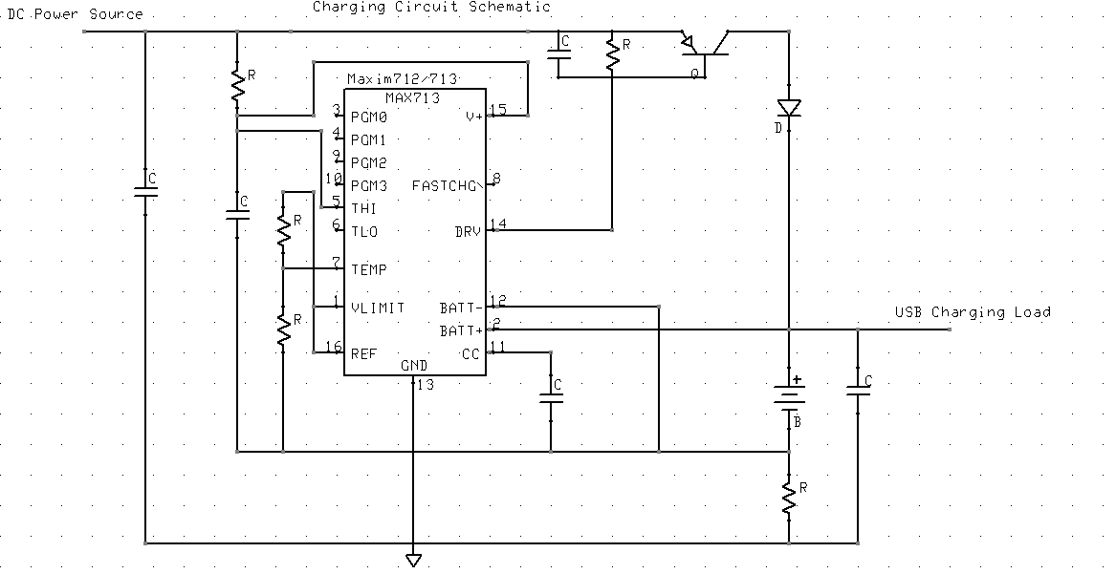

Fig. 6. Charging circuit source.

The current-sense resistor allows the battery charge current to be regulated while supplying the battery’s load, which is useful for the project. The Maxim chip can charge 1 to 16 cells, which is sufficient for the needs of the UCF. The chip can also supply the battery’s load while charging, which would be the USB load or any device to charge. The project can charge the device as well as the battery from the DC source or wall wart. It can automatically switch from fast charging to trickle charging which increases the efficiency of the unit. Another effective feature of the MAX712 is the very low current draw when the battery is not charging. The current is 5µA at max current draw when the battery charger is not charging, which makes the entire battery system efficient. The MAX712 is an efficient option for the battery charging unit using nickel metal hydride cells.
A fast constant current source is used in charging the nickel metal hydride cells, and the time it takes to fully charge will depend on the amount of current as well as the capacity of the battery. A buck converter can be the constant current source in order to charge the battery. It is critical to charge the batteries safely and in the appropriate manner. In order to charge the batteries safely an end of charge circuit will be implemented to detect when the battery system is fully charged. The main ways to detect such a state would be by voltage, temperature and a timer. Obviously the voltage of the battery can be obtained and assist in determining the state of the battery. Likewise, as discussed earlier, the temperature of the battery will aid in determining that the battery is fully charged based on a certain temperature range that can be triggered by either a temperature sense resistor configuration or a digital one pin temperature integrated circuit. The timer is implemented within the programming of the PIC so that if one of the previous checks fail, either voltage or temperature detection, then the timer would kill the charging of the battery so the battery will no damage.
An extremely efficient way of utilizing the energy from the solar panels is a critical portion to the design of the battery charger. The energy generated from the solar panels must be completely stored by the battery system. One way of maximizing the power of the energy generated by the panels is to regulate the voltage from the panels. Since at different points in the day the panels are generating different voltage levels, it becomes important to feed the battery system with energy to store. An efficient voltage regulator can be useful in the design of the battery system to optimize the power to the battery. The regulator assists in the effort to maximize the performance and limits the safety hazard from the battery system. By not allowing the battery system to overcharge or drain too much energy at one time, the regulator improves the lifespan also of the battery pack. Efficient use and reliability from the product is important to the user.
The charging unit ensures that optimum use is made of the energy inside the battery to power the portable products. It also has to minimize the risk of damage to the electronic device. The inputs of the system are wall charger and solar and kinetic energies. The system has a USB connector which is used to easily connect an MP3 player, camera or any such device for charging. In order to ensure an efficient and reliable product, the right battery is critical. The USB port draws power from the battery which carries more than the necessary 5V for the devices. A DC-DC converter is used to step-down the voltage from the battery to the device for a proper charge. The converter is an optional link so the unit is efficient in the use of voltage and decreases the amount of dissipated heat it would release otherwise. The DC-DC converter is used in the battery system since the voltage of the batteries is higher than the required 5V necessary to power USB driver devices. As far as efficiency, it is optimal to convert the battery voltage into a minimum supply voltage needed by the load.
E. Microcontroller
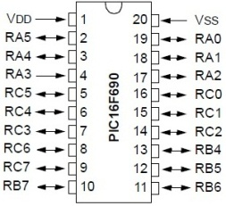
The microcontroller used for the project is Microchip’s PIC16F690. The operating voltage for the device is 2.0V - 5.5V. This 20-pin MCU performs the basic functions that the UCF requires, including all the analog-to-digital conversions, controlling transistor switches and relays, and monitoring battery life. One of the special features of this microcontroller is its low power consumption. It also contains 12 A/D channels with 10 bit resolution which allows for more accurate sampling values. As can be seen in Figure 7, the PIC16F690 has 17 I/O pins and 1 input only pin, which allows for a couple extra pins for future expansion.

Fig. 7 PIC16F690 has a 20-pin configuration, with 17 I/O pins and 1 input only pin.
F. LCD
The display is a 16x2 LCD with a backlight and is controlled by the standard Hitachi HD44780 driver. The information to be displayed on the LCD is sent from the UCF microcontroller to the four data pins D4-D7 on the LCD. The LCD contains eight pins, but to save microcontroller pins, the data is sent in four-bit nibbles. The HD44780 driver receives the information from the data pins and is then instructed to output the character at a specific location on the LCD. Figure 8 shows the LCD pin setup, and it is apparent that data pins D0-D3 and the R/W pin are grounded since they are not used. Also evident is the 10 kΩ potentiometer used to control the LCD character contrast.
Fig. 8. LCD pin setup.
G. Analog-to-Digital Conversion
The PIC16F690 contains twelve channels available for analog-to-digital conversion. The UCF’s objectives require four channels to be sampled periodically for display to the user. The four ADC requirements are battery, wall, solar, and kinetic voltage. The microcontroller samples each source multiple times a second and uses the Equation 4 to compute the display value of the source voltage. Equation 4 takes the raw sampled value and multiplies it by the +5V board power and divides by the 10-bit resolution (2¹⁰ = 1023), and finally divides that result by the voltage divider factor to achieve the correct ADC value for display.

$ADC Value=\frac{\left(\frac{{ADC}_{raw} x V_{ref}}{1023}\right)}{\left(\frac{V_{out}}{V_{in}}\right)}$ (4)

Equ. 4. This equation shows how the ADC display value is calculated using 10-bit resolution.

III. Schematic
A. Overview Block Diagram of Entire System
The Universal Charging Friend consists of several power supply options for charging the battery. A PIC and an LCD have also been added to the design to give the user an interface to the unit so the user understands what is happening with the charging process real time. The unit also includes a USB port to allow discharging of the battery to any 5V electronic device.

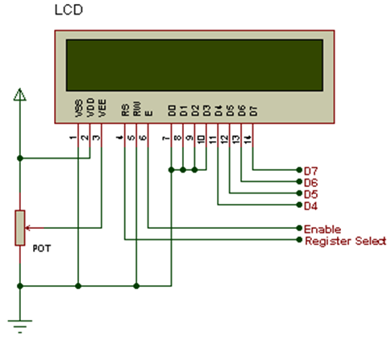
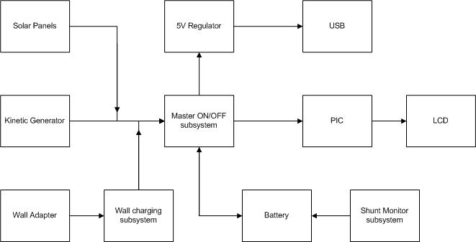

Fig. 9. Simplified block diagram of the UCF design.
B. Power Control schematic
The power control schematic consists of the main push button used to turn on and off the UCF unit, a linear regulator, an inverter and a latch. When the push button is first pushed in order to turn on the unit a pulse is sent through (from the battery) the inverter and into the latch. This will switch the latch down and connect the main power ground to the battery ground and power up the PIC and LCD and any other components in need of a power supply. If the button is pushed for more than three seconds an interrupt will be sent to the PIC and then the PIC will send a pulse through to the latch in order to reset the latch and shut down the unit. Also, if the UCF unit is already on and the push button is pressed and released an interrupt will be sent to the PIC telling the PIC to light up the backlight of the LCD for ten seconds. The LCD will then dim out again to conserve power.
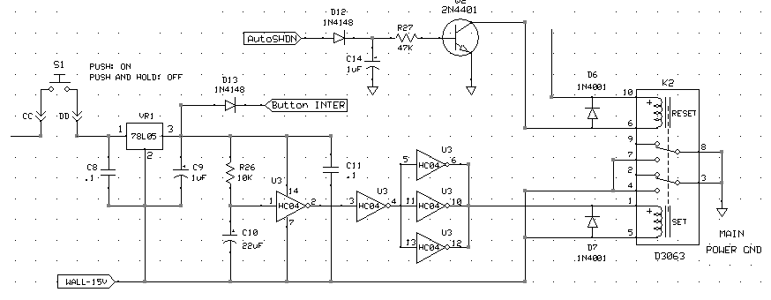
Fig. 10. This is a section of the full UCF schematic. This section is displaying the Main Power system.
C. Wall Charging Schematic
The wall charging schematic is centered around the MAXIM chip. The design is very closely related to what is found in the MAXIM713 datasheet. A dual LED has been added to the design as well to provide an interface to the user showing whether the wall adaptor is trickle charging or fast charging the battery. If the battery is being trickle charged, the battery is nearly full and the LED will be blue. If the battery is fast charging, the LED will be red.
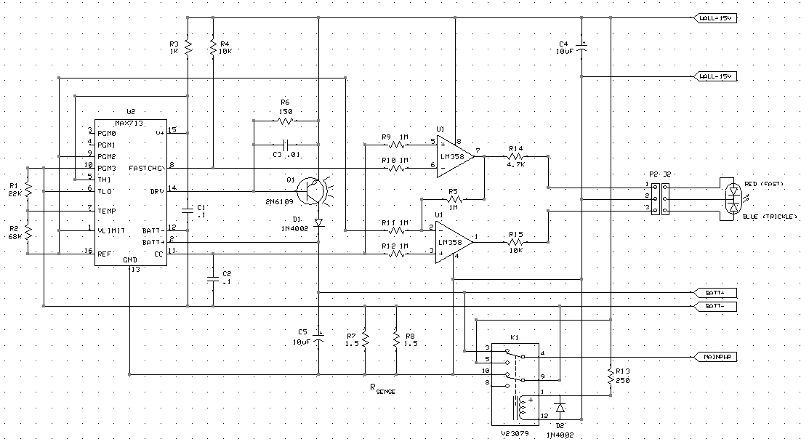
Fig. 11. This is a section of the full UCF schematic. This section is displaying the Wall Charging system.

D. I/O Schematic
The PIC and the LCD make up the I/O portion of the schematic. The PIC’s main function in the UCF is to use its internal ADC’s to sample voltages from the solar power, kinetic power, wall adapter power and battery Voltage. The PIC is also wired to many parts of the system to wait for any interrupts including the two current shunt monitors and the push button interrupts. Also, the PIC will automatically shut down the unit if the battery gets too low by sending a pulse through to the latch which in turn shuts off the UCF. The LCD was added to display all of this information to the user.
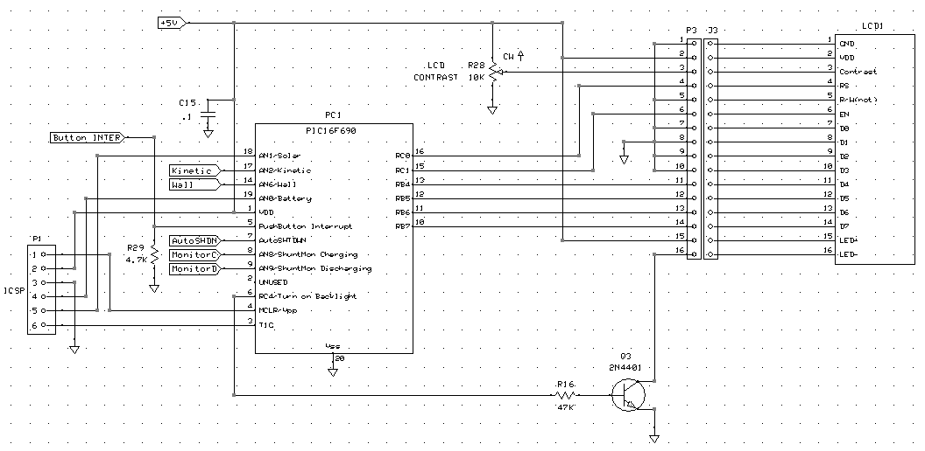
Fig. 12. This is a section of the full UCF schematic. This section is displaying the I/O system.
E. ICSP Header
The ICSP header was also added to the schematic so that it would be included in the PCB design. This would allow the group to program the PIC chip directly from the board instead of having to move the PIC chip back and forth between the PIC development board and the UCF printed circuit board.
F. Current Shunt Monitors
The current shunt monitors were added to the design in order to accurately measure the current going through the shunt resistor and into or out of the battery. The shunt monitors measure the voltage across the shunt resistor and then amplify the voltage fifty times. This measurement is sent to the PIC where the current can then be calculated using Ohm’s law since the shunt resistor value is known and the voltage across the resistor is known.

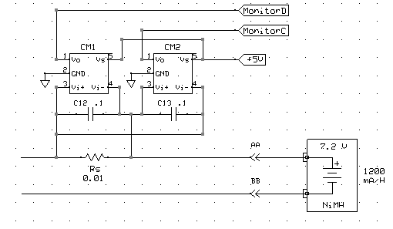
Fig. 13. This is a section of the full UCF schematic. This section is displaying the Shunt Monitor system used for measuring the current.

IV. PCB Design
The main objectives of the PCB were size, durability, cost and appearance. The board needed to be small enough to fit inside of the UCF enclosure and be safely mounted to a side panel of the UCF to prevent damage to either the board or the enclosure unit. We also wanted the board to look professional, so it was decided to design a PCB (instead of using a prototype) and have it manufactured by ExpressPCB. The two pieces of software used to design the schematic and the PCB were ExpressSCH and ExpressPCB, both are free and readily available to the public.
It was decided that all the circuitry for the entire project would be placed on one main PCB and mounted safely inside the UCF enclosure unit to consolidate on space. Four large holes can be seen in figures 14 and 15. These are the holes that will be used for mounting screws. Compromises were necessary when designing this board. An example of this was the fact that an inner main ground plane and +5V power plane were necessary to reduce the number of traces and required space, but the trade-off was paying an increased price on the board. Thicker traces were necessary in many parts of the design due to the high amperage running from the power sources to the battery.
Designing the PCB given the amount of space to work with was a challenge. As stated earlier, an inner ground and power plane needed to be added to the design, which significantly dropped the number of traces needed. Also, the top signal layer of the PCB was used as a separate ground for the battery. The bottom signal layer of the PCB was divided and a section of this bottom layer was used as another separated ground for the wall charging circuit. The final size of the board is 6.50 inches by 2.60 inches. Almost all of the components used on this board are through-hole, and only two components are surface- mount. These two components, the INA-193 current shunt monitors, were only available as surface mount parts. The group decided to use primarily through-hole components since these parts are much simpler to solder onto the board.

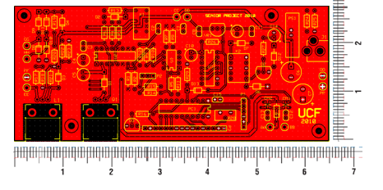

Fig. 14. This is the top signal layer of the UCF PCB design as seen in ExpressPCB. This top copper plane is also used as the ground for the wall charging circuitry.

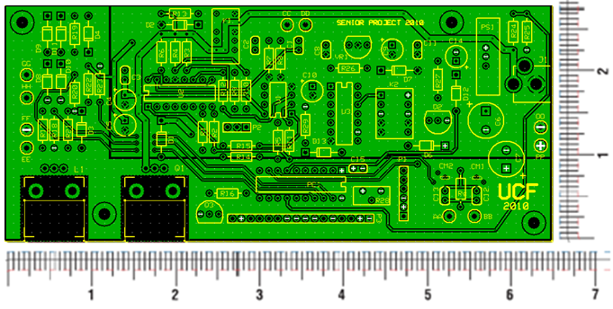

Fig. 15. This is the bottom signal layer of the UCF PCB design as seen in ExpressPCB. Note the division of the copper plane used for the Battery ground.

V. Conclusion
The UCF combines kinetic and solar energy to a portable battery charging system in order to maximize the power for a range of handheld devices. This paper presents the design and implementation of an efficient charging system which utilizes kinetic, solar, and grid power to charge common electronics devices. The small size of the UCF makes it easy to transport within backpacks for trips. The LCD screen mounted on one of the sides of the device can notify the user of the state of the unit and status of the batteries within the charger. The solar and kinetic feature of charging devices not only makes the task efficient but also cost effective as well as environmentally friendly. Applications of the UCF are limitless, consisting of such purposes as camping and simply charging a cell phone for a few hours of talk time.

Acknowledgement

The authors wish to acknowledge the assistance and support of Tony Culotta from QinetiQ North America and Mehdi Daryadel from Core Tec. Without their help and experience, this project would not be nearly as good. Each group member learned a vast amount of knowledge from the experienced professionals and we hope to share our knowledge with other students in the future.
We would also like to thank the group in machine learning for allowing us to build the UCF structure in their labs. Their equipment and experience was very valuable in putting together a working component.
Lastly, we would like to acknowledge and thank all our coworkers and friends who have supported us in our endeavors.

References

[1] "Silicon Solar." 2010.http://www.siliconsolar.com/ admin/kt_download.php?document_id=47362 (accessed November 20, 2010).
[2] W. H. Cantrell, “Tuning analysis for the high-Q class-E power amplifier,” IEEE Trans. Microwave Theory & Tech., vol. 48, no. 12, pp. 2397-2402, December 2000.
[3] W. H. Cantrell, and W. A. Davis, “Amplitude modulator utilizing a high-Q class-E DC-DC converter,” 2003 IEEE MTT-S Int. Microwave Symp. Dig., vol. 3, pp. 1721-1724, June 2003.

[4] Silicon SolarW. H. Cantrell, and W. A. Davis, “Amplitude modulator utilizing a high-Q class-E DC-DC converter,” 2003 IEEE MTT-S Int. Microwave Symp. Dig., vol. 3, pp. 1721-1724, June 2003.
[5] Joseph A. Paradiso, Thad Starner, Energy Scavenging for Mobile and Electronic Devices, Pervasive Computing
[6] S.P. Beeby, R.N. Torah and M.J. Tudor. Kinetic Energy Harvesting. University of South Hampton, UK. January, 2008.
[7] C.R. Saha, T. O’donnell, N. Wang, P. McCloskey. Electromagnetic Generator for Harvesting Energy from Human Motion. Sensors and Actuators, March 15, 2008
[8] Maxim NiCd/NiMH Battery Fast Charge Controllers MAX712/713 datasheet. 2008.

[9] Harrison, Mike. "Which Is Better, PIC or AVR ? Let's Have a Heated Debate....." Mike's Electric Stuff. Web. <http://www.electricstuff.co.uk/picvsavr.html>.
[10] Limor. "PIC vs. AVR Smackdown." Ladyada.net. Web. <http://www.ladyada.net/library/picvsavr.html>.
[11] Microchip. Microchip. Web. 2010. <http://www.microchip.com/>.
[12] Quick, Darren. "NanoWatt XLP Microcontrollers Claim World’s Lowest Sleep Current." Gizmag Emerging Technology Magazine. 30 Apr. 2009. Web. <http://www.gizmag.com/nanowatt-xlp-microcontrollers/11575/>.

Biographies
Melanie Cromer:

Melanie Cromer is currently an undergraduate studying electrical engineering at the University of Central Florida. Her interests lie within Power Systems and may pursue studies within Biomedical Engineering in the future. She is currently interning with a company, Core Tec, LLC, that focuses on digital communications technology.

Tristan Byers:

Tristan Byers served five years in the United States Navy and is currently an undergraduate studying electrical engineering at the University of Central Florida. His focus of study is semiconductors and micro electronics.

Michael Matthews:

Michael Matthews is currently an undergraduate studying electrical engineering at the University of Central Florida. He also maintains a full-time position for QinetiQ North America at the Kennedy Space Center as a telemetry engineering aide, and will become a telemetry engineer upon graduation.

Alfred Berrios:

Alfred Berrios is currently an undergraduate studying electrical engineering at the University of Central Florida. He plans to pursue a Master’s degree in electrical engineering within the area of digital signal processing and systems.

